EXPT NO: 7 | OVER-PLOTTING REDUCTION TECHNIQUES
DATE: 16.02.2026 | OVER-PLOTTING REDUCTION TECHNIQUES

PRE-LAB QUESTIONS
- Why is over-plotting common in big data visualization?
Over-plotting is common in big data visualization because large datasets contain many observations that are mapped to a limited plotting area. When multiple data points share similar or identical values, they overlap on the graph, making individual points indistinguishable.
- How does data density affect perception?
High data density can obscure patterns by causing points to overlap, which reduces visual clarity. Dense regions may appear darker or more prominent, leading viewers to misinterpret frequency or importance, while sparse regions may be overlooked.
- What trade-offs exist between detail and clarity?
Including more detail improves data completeness but reduces readability due to clutter. Simplifying or aggregating data improves clarity but may hide important variations or outliers. Effective visualization balances information richness with visual interpretability.
- How do AI datasets increase visualization complexity?
AI datasets are often high-dimensional, large-scale, and continuously updated. Visualizing such data requires dimensionality reduction and advanced plotting techniques, which can introduce information loss and make interpretation more challenging.
- Why is over-plotting a serious analytical risk?
Over-plotting can hide trends, clusters, and outliers, leading to incorrect conclusions. It may falsely suggest uniform distributions or mask relationships between variables, reducing the reliability of analytical insights.

OBJECTIVE : To apply techniques that reduce visual clutter in large-scale datasets.

SCENARIO A social media analytics company visualizes millions of user interactions to study engagement patterns.

IN-LAB TASKS (Using R Language) • Apply alpha blending • Implement jittering techniques • Use aggregation and binning

CODE:
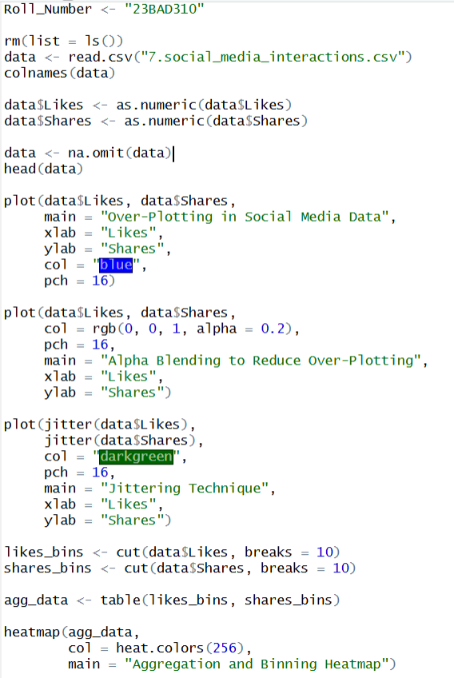S

OUTPUT:
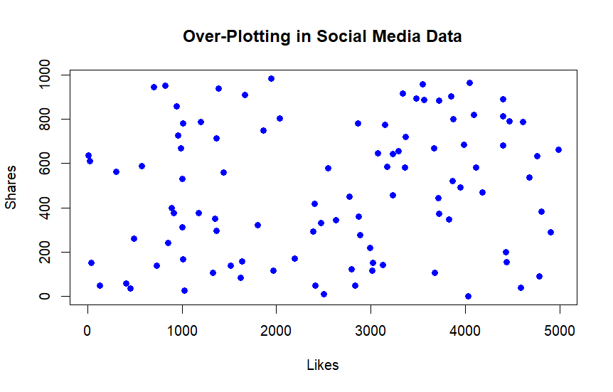
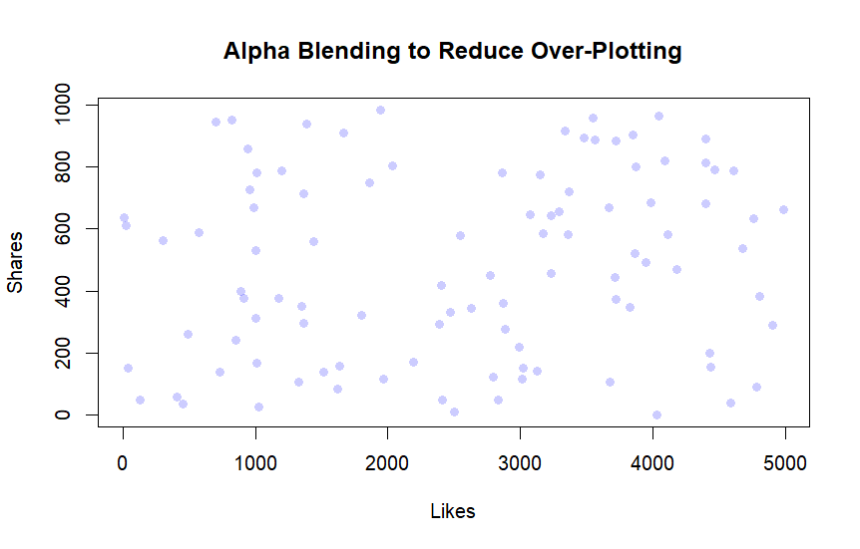
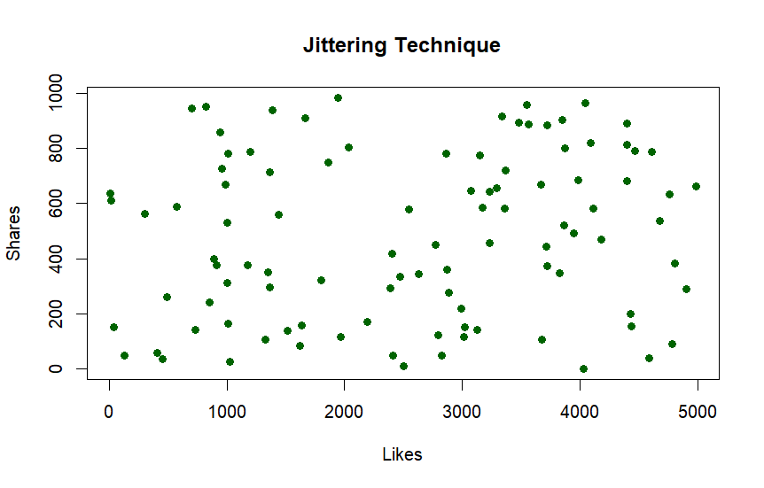
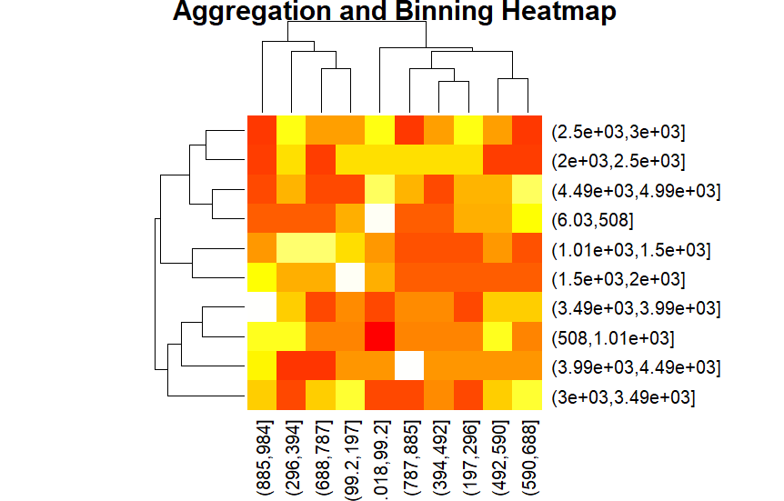

POST-LAB QUESTIONS
- Which technique provided the best clarity and why?
Techniques such as transparency (alpha blending) and aggregation provided the best clarity because they reduce visual clutter while preserving overall data distribution. These methods allow dense regions to be identified without completely obscuring individual data points.
- How does over-plotting distort analytical conclusions?
Over-plotting can conceal trends, clusters, and outliers, causing analysts to underestimate variability or miss important patterns. This distortion may lead to incorrect assumptions about relationships between variables or data uniformity.
- When should aggregation be preferred over raw plotting?
Aggregation should be preferred when working with very large datasets where individual data points overlap excessively. It is especially useful when the goal is to understand overall trends, densities, or summaries rather than individual observations.
- How do these techniques support scalable AI analytics?
These techniques improve scalability by summarizing large volumes of data into interpretable visual forms. By reducing noise and complexity, they enable faster insight generation and more reliable decision-making in AI-driven analytics systems.
- Explain real-world consequences of ignoring over-plotting.
Ignoring over-plotting can lead to misinformed decisions, such as inaccurate risk assessment, flawed business strategies, or incorrect scientific conclusions. In fields like finance, healthcare, and AI model evaluation, such errors can result in significant economic loss or safety risks.

LEARNING OUTCOME: Students master over-plotting reduction for big data visual analytics.
ASSESSMENT
Description | Max Marks | Marks Awarded
Pre Lab Exercise | 5
In Lab Exercise | 10
Post Lab Exercise | 5
Viva | 10
Total | 30
Faculty Signature

